

NSSA.221.601

Systems Administration I

Site Book

Done by: Rania Kanaan, Suhaila, Alia, Marwa, Saeed

Domain: rak7848, saa6070, aaa6056, mim4143, snf7932

Table of contents

# 

# **LIST OF TABLES AND FIGURES**.............................................................................. **3**

# **Change Control**............................................................................................................ **4**

# **Overview**..................................................................................................................... **5**

# **Virtual Environment Setup**.......................................................................................... 5

# **RLES Installation and Configuration**............................................................................. 5

# **Git Version Control**....................................................................................................... 12

## **Network topology and device configurations ..................................................... 5 Servers ...................................................................................................................... 7**

# **Windows Server 2022** ................................................................................................. 7

# **Storage Server** ............................................................................................................... 7

# **RAID and Partition setup** .............................................................................................. 7

# **FTP, Samba and RSYNC setup** ...................................................................................... 8

## **Services............................................................................................................................ 9**

# **Active Directory** ........................................................................................................... 9

# **Setup** ............................................................................................................................. 9

# **DHCP** ........................................................................................................................... 11

# **DNS**............................................................................................................................... 11

# 

# **LIST OF TABLES AND FIGURES**

# 

# **Figure 1**: Network Topology ……………………………………………………………………….. 6

# **Table 1**: Devices’ software and hardware information…………………………….………………... 6

# **Table 2**: Test Users for Active Directory …………………………………………………………… 10

# **Figure 2**: Active Directory Topology ……………………………………………………………… 11

# **Table 3**: Group policies…………………………………………………………………………… 10

# **Table 4**: DHCP Scope Verification………………………………………………………….…… 10

# **Table 5**: Persistent Mount Verification ..………………………………………………………… 9

# **Table 6**: 10.168.192.in-addr.arpa Reverse lookup zone records …………………………………… 12

# **Table 7**: rak7848.com Forward lookup zone records …………………………………………….. 12

# 

Change Control

| Creation/Update Description | Date | By |
| --- | --- | --- |
| Initial Site Book creation | **9/12/2023** | Rania Kanaan, Suhaila, Alia, Marwa, Saeed |
| Lab 2 (Active Directory ) | **11/10/2023** | Rania Kanaan, Suhaila, Alia, Marwa, Saeed |
| Lab 3 (Git and Linux Local Account Management ) | **11/18/2023** | Rania Kanaan, Suhaila, Alia, Marwa, Saeed |
| Lab 4 (RAID) | **11/26/2023** | Rania Kanaan, Suhaila, Alia, Marwa, Saeed |
| Lab 5 (File Services) | **12/1/2023** | Rania Kanaan, Suhaila, Alia, Marwa, Saeed |

Overview

RIT New York operates the iSchool Private Cloud, called the Distance Learning Simulation System (RLES), a state-of-the-art, cloud-based virtualization system. This state-of-the-art platform includes many virtual machines, and this provides the ability to design virtual environments and control them. This allows the establishment of laboratories accurately and the design of a good network infrastructure, which offer a wonderful practical and educational opportunity.

Virtual Environment Setup

A virtual infrastructure containing, a Rocky Linux client, a pfSense router, a Windows 10 client, a Windows 2022 server, and a storage server is deployed using RLES. Choosing virtual infrastructure has the following advantages:

1. RLES allows us as learners to investigate and try out different experiments without damaging any physical materials of our main device. This helps us reduce the risks and ensures the security of learning in a safe environment.
2. RLES allows us to access our deployments anywhere and whenever we need with just powering on our deployments and starting to explore.

Network Topology

Our network topology includes four main devices: Pfsense, Rocky Linux, Windows 10, and Windows Server. Each of these devices has been set up with different IP addresses, including our domain name, as well as computer names. They have been configured to play specific roles in this topology.

# **Figure 1**: Network Topology

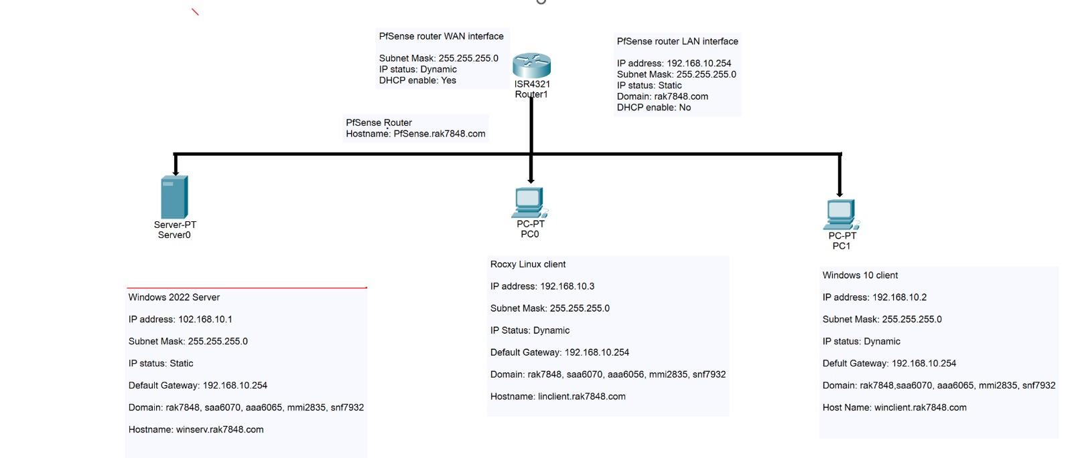

**Table 1**: Devices’ software and hardware information

| Device Name | Device  Type | Hostname | Operating  System | Storage information |
| --- | --- | --- | --- | --- |
| pfSense-2721 | pfSense  router | pfSense.rak7848.com | FreeBDS | 16GB |
| WinServe202 2-0370 | Windows  Server 2022 | winserv.rak7848.com | Windows  server 2022 datacenter | 60GB |
| Win10-4557 | Windows 10 | winclient.rak7848.com | Windows 10  Enterprise | 50GB |
| RockyLinux8 -1112 | Rocky Linux | linclient.rak7848.com | Rocky Linux  8.7 | 62GB |

Active Directory

The Active Directory is a system administrator that allows us to manage user accounts, devices, and authentication. In the Windows Admin Center, we created an organizational unit and added three users to it. Later on, in Windows Server using PowerShell, we have also added three additional users.

**Table 2**: Test Users for Active Directory

| **Full Name** | **Login Name** | **Password** | **Domain** |
| --- | --- | --- | --- |
| Rania Kannan | Rania | 141218ps | rak7848.com |

# 

# **Figure 2**: Active Directory Topology

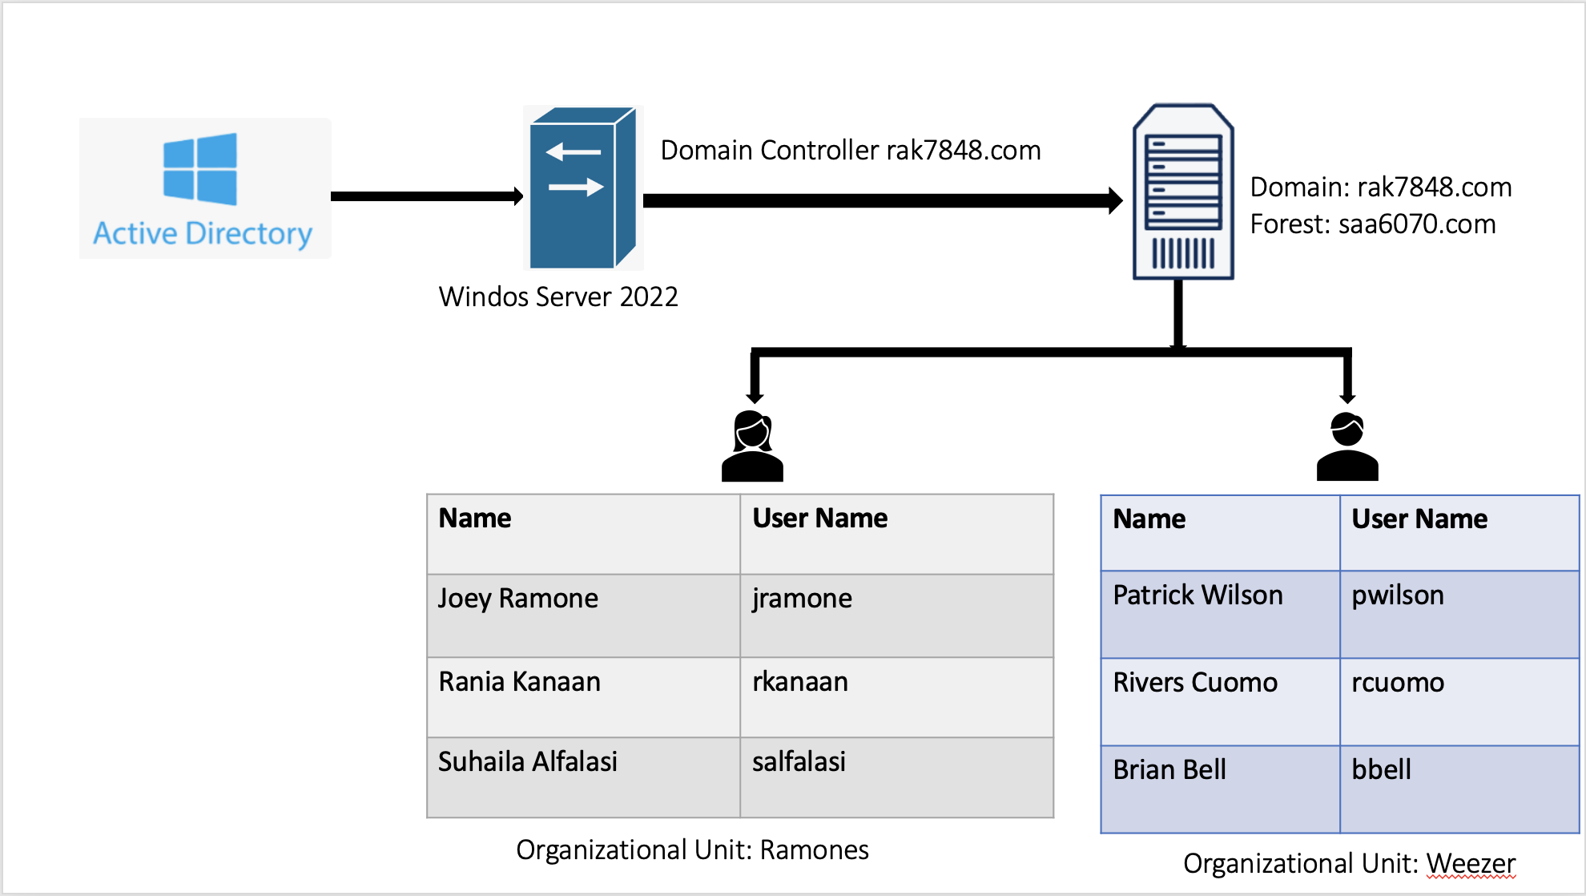

Group Policies:

# **Table 3**:Group policies

| Name | Purpose |
| --- | --- |
| Control Panel | To control the access of creating/managing the user accounts. |

DNS

In Windows Server 2022, through server management, the Domain name server (DNS) has been installed and configured. The DNS installation and setup process is made more accessible with Windows Server 2022's server administration tools. Network administrators may effectively configure and manage DNS functions by using the server administration interface, which ensures smooth domain resolution. Managing responsibilities connected to the domain improves the server's overall performance and dependability.

DHCP

Winserv, running on Windows Server 2022, acts as a virtual machine responsible for providing DHCP services to the local network. The specified IPv4 range is from 192.168.10.1 to 192.168.10.254, In addition, the default gateway IP address, 192.168.10.254, was intentionally omitted. The LAN interface of the pfSense router is configured with the default gateway IP address.

# **Table 4**: DHCP Scope Verification

| ScopeID | Subnet Mask | Name | State | Start Range | Lease Duration |
| --- | --- | --- | --- | --- | --- |
| 192.168.10.0 | 255.255.255.0 | 221course | Active | 192.168.10.1 | 8.00:00:00 |

Git Version Control

The "Solace" server is a git repository that can be entered through the RIT VPN (Cisco Secure Client). These commands can be used to get access using a secure shell (ssh):

ssh rak7848@solace.ist.rit.edu/home/MAIN/rak7848/repos/

or using

git clone ssh://rak7848@solace.ist.rit.edu/home/MAIN/rak7848/repos/

Setting up the Storage Server

In this RAID 1, we're building a mirrored array with the mdadm utility. The array gets divided into sections using a Master Boot Record (MBR) table, which involves creating primary, extended, and logical parts using the fdisk utility. We use specific commands in the computer terminal, like mdadm, to set up the RAID and specify the level and paths for the unused drives. Afterward, we use the command cat /proc/mdstat to check and see how the RAID is doing, getting details about its current status.

Creating a RAID 5 with a GPT Partition Table involves using the mdadm utility to set up the RAID 5 with three specific drives, and then partitioning it using the gdisk command. The steps include creating a new GPT partition table, specifying partitions, formatting them with a chosen file system, and finally, mounting the partitions in directories.

# **Table 5**: Persistent Mount Verification

| Device | UUID | Mount Point | File Type |
| --- | --- | --- | --- |
| /dev/sdb | "c968bc5a-36e8-4a41-9467-9948c50228fa" | /media/samba | xfs |
| /dev/md0p1 | "4b979dcf-fa30-4a4a-83c2-175f51547b37" | /media/nfs1 | xfs |
| /dev/md0p5 | "4fe67518-e4bc-420c-b5c2-91c22b5754c8" | /media/nfs2 | xfs |
| /dev/md1p1 | "224c1483-fb76-494d-8909-6d4e75207125" | /media/samba1 | xfs |
| /dev/md1p2 | "9b60626b-33d9-42d8-be03-be297eb6cf52" | /media/samba2 | xfs |
| /dev/md1p3 | "b80c9d41-90d5-4e5e-862a-Oalde4e39081" | /media/samba3 | xfs |

Reverse Lookup Zone:

A reverse lookup zone was set up to facilitate the resolution of IP addresses to hostnames within the network. Currently, each zone's data contains extensive information on all five linked devices. Updated records of the reverse lookup zone now included information on the Storage Server, Windows Server 2022, Windows 10 client, pfSense router, and Rocky Linux client. These entries cover the Reverse lookup zone.

**Table 6**: 10.168.192.in-addr.arpa Reverse lookup zone records

| **IP Address** | **Name** |
| --- | --- |
| 11.10.168.192.in-addr.arpa | winclient.rak7848.com |
| 13.10.168.192.in-addr.arpa | linclient.rak7848.com |
| 1.10.168.192.in-addr.arpa | winserv.rak7848.com |
| 254.10.168. 192.in-addr.arpa | pfSense.rak7848.com |
| 12.10.168.192.in-addr.arpa | storageserv.rak7848.com |

Forward Lookup Zone:

By default, just the server is included in the forward lookup zone that is created. An extra forward lookup zone was established to aid in the translation of hostnames to IP addresses within the network. Next, particular data for each of the five linked devices—the Storage Server, Windows Server 2022, Windows 10 client, pfSense router, and Rocky Linux client—was added to the entries in the forward lookup zone. The website information for rak7848.com in particular has been added to the forward lookup zone's data.

**Table 7**: rak7848.com Forward lookup zone records

| **Name** | **IP Address** |
| --- | --- |
| ForestDnsZones.rak7848.com | 192.168.10.1 |
| linclient.rak7848.com | 192.168.10.13 |
| winclient.rak7848.com | 192.168.10.11 |
| DomainDnsZones.rak7848.com | 192.168.10.1 |
| pfSense.rak7848.com | 192.168.10.254 |
| rak7848.com | 192.168.10.1 |
| storageserv.rak7848.com | 192.168.10.12 |
| winserv.rak7848.com | 192.168.10.1 |

# 

FTP, Samba, RSYNC Setup:

The focus here was on preparing a comprehensive list of file sharing by configuring services such as FTP, Samba, RSYNC, and NFS. The Linclient and Winclient storage servers participate in this setup. The FTP server works on port 21 and allows all anonymous and known users to log in through it. As for the Samba server, it works on ports 445 and 139. It supports the passwords for four unique users, and they are organized through a system called “writers.” A Samba directory is created with the ownership of the corresponding group.

The RSYNC server is connected. Which binds to port 873, in the /media/rsync directory, to allow traffic on ports 139, 21, 445, and 873. Protection serious rules are configured. NFS configuration includes exporting the /media/nfs1/weezer directory, with firewall rules to support NFS. linclient successfully mounts /media/nfs1/weezer as its network file system, while drive Z is anonymously connected to NFS on winclient.

The infrastructure for sharing files within the network is strong by providing these services. This LAB was associated with focusing on securing FTP connections, configuring Samba servers, and extending the Linux file system using NFS, in addition to the importance of FTP, Samba, and NFS in facilitating file sharing across different systems.